CUSTOMER CHURN PREDICTION IN TELECOM INDUSTRY
(Machine Learning Based Customer Retention System)
Design and Implementation
Department of Computer Science and Engineering, TKR College of Engineering and Technology (Autonomous)
Batch A14 (CSE-A) · Academic year [ACADEMIC YEAR]
Table 1: Project team
S.No. | Student name | Roll number
1 | ANANTULA SAI NIKHILA SRAVANI | 23K91A0512
2 | AVULA ANUDEEP | 23K91A0518
3 | B SANDEEP | 24K915A0503
4 | DARAGANI VINOD KUMAR | 23K91A0558

Project guide: B. SRIKANTH, Assistant Professor, Department of CSE
Chapter and section numbers quoted in the text (for example Section 6.6 or Chapter 8) refer to the full project report, 17.Final Document. Figures and tables in this document are numbered from 1.

1. DESIGN

5.1 Design Principles
• Core independent of the interface. All data, modelling and business logic lives in src/ and imports nothing from Streamlit or FastAPI. The Streamlit pages and the FastAPI routes are thin callers, so the two interfaces cannot disagree.
• Explainable by construction. Every score can be traced: coefficients or importances for the model, a list of drivers for the customer, a named rule for each retention suggestion.
• Honest evaluation. The preprocessor is fitted on the training split only, SMOTE touches only the training split, and the best model is chosen on F1 and not on accuracy alone.
• Fail early and clearly. Settings and uploads are validated on the server and rejected with a plain message (401, 404, 409, 422) before any computation starts.
• No hidden services. Nothing leaves the machine: no external API, no language model, no database server.

5.2 System Architecture
The system has four layers. The presentation layer is the React interface (port 5314, which proxies /api to the API) and the original Streamlit interface (port 8501). The application layer is the FastAPI service in backend/ with 31 route handlers, bearer-token authentication and an in-memory AppState. The core layer is the pure-Python package src/, which both interfaces call and which contains no interface code. The data layer is the CSV file, the three joblib files of the saved model and the in-memory state. There is no SQL database.
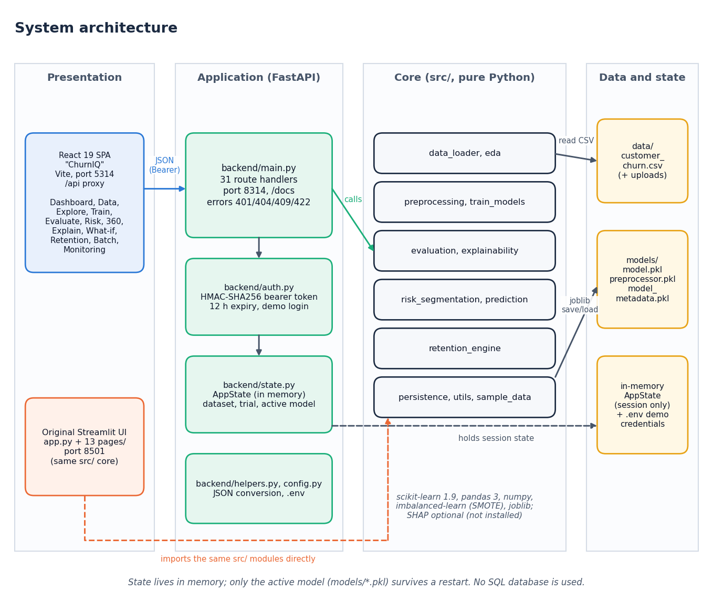
Figure 1: System architecture of ChurnIQ
The code base has about 1,183 lines in src/ (12 modules), 1,052 lines in backend/, 1,353 lines in the 13 Streamlit pages and the React interface in frontend/. The FastAPI layer was added for the web interface and changes nothing in src/.

5.3 Module Design
Table 2: Modules of the core package src/
Module | Lines | Responsibility
data_loader.py | 180 | Read a CSV; detect target and ID columns; coerce numeric-looking text; profile (missing, duplicates, warnings); normalise the target to 0/1; validate before training
preprocessing.py | 102 | Drop duplicates; stratified train/test split; ColumnTransformer (median + StandardScaler, most-frequent + OneHotEncoder); SMOTE on the training split
train_models.py | 93 | MODEL_REGISTRY (LR, DT, RF, GB, HGB); train the selected models under an imbalance strategy; select the best model on a chosen metric
evaluation.py | 56 | Accuracy, precision, recall, F1, ROC-AUC, confusion matrix, ROC and precision-recall curves
explainability.py | 169 | Global importance (built-in, permutation, optional SHAP); local explanation with a coefficient-times-value fallback; readable feature labels
risk_segmentation.py | 49 | Score every customer, assign risk bands, sort, summarise the distribution
prediction.py | 63 | Score customers; validate batch columns; build the batch prediction table with optional top drivers
retention_engine.py | 137 | Ten IF/THEN rules plus two fallbacks that turn a profile, probability and band into retention suggestions
persistence.py | 41 | Save and load model.pkl, preprocessor.pkl and model_metadata.pkl with joblib
eda.py | 98 | KPIs and the charts of the Explore page
sample_data.py | 120 | Seeded synthetic Telco-style data generator
utils.py | 75 | Risk-band assignment from editable thresholds; tenure and charge groups; safe numeric coercion

The API layer has five modules: main.py (route handlers), auth.py (token creation and checking), state.py (the in-memory AppState), helpers.py (conversion of pandas and numpy values to JSON) and config.py (settings read from .env).

5.4 Data Flow
One process, the ChurnIQ system, exchanges data with the analyst and with the customer data source and uses three stores: the working dataset and session state, which are in memory, and the model files on disk.
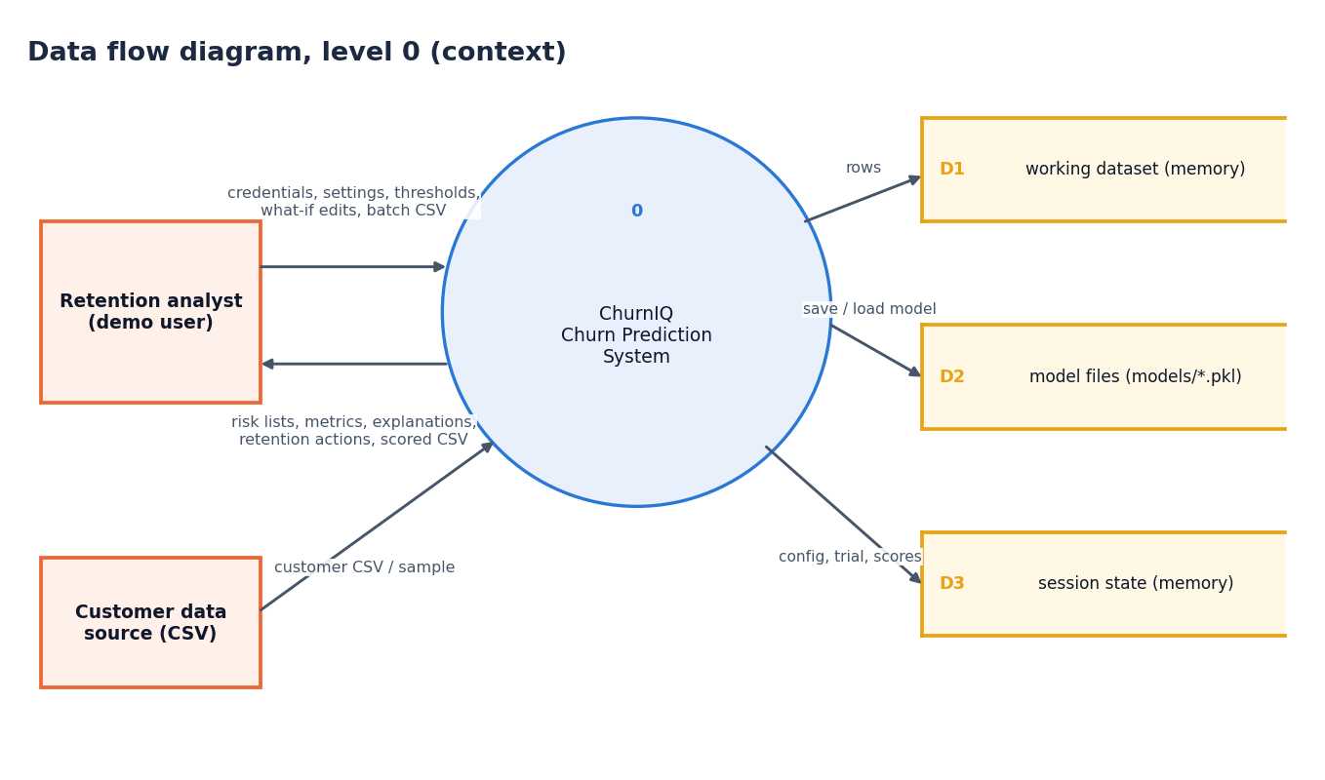
Figure 2: Data flow diagram, level 0 (context)
Six processes: authenticate (1.0), load, profile and prepare (2.0), train, evaluate and select (3.0), score and segment risk (4.0), explain, what-if and retention (5.0) and batch scoring and monitoring (6.0). The model artefacts written by 3.0 and read by 4.0 and 6.0 are the link between training and use.
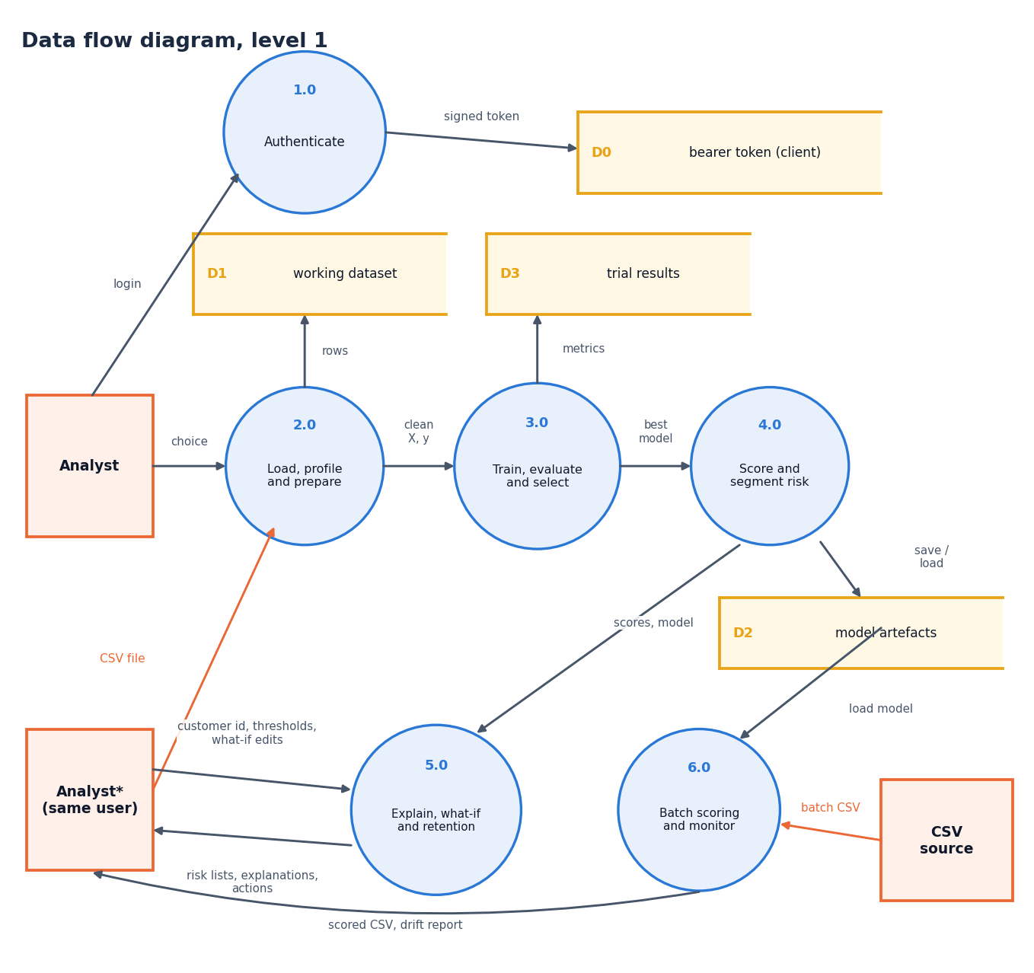
Figure 3: Data flow diagram, level 1
Process 3.0 expanded into seven sub-processes: stratified split, preprocessor fit on the training split only, imbalance handling, model fitting, evaluation on the test split, selection of the best model and saving of the artefacts. SMOTE touches only the training split.
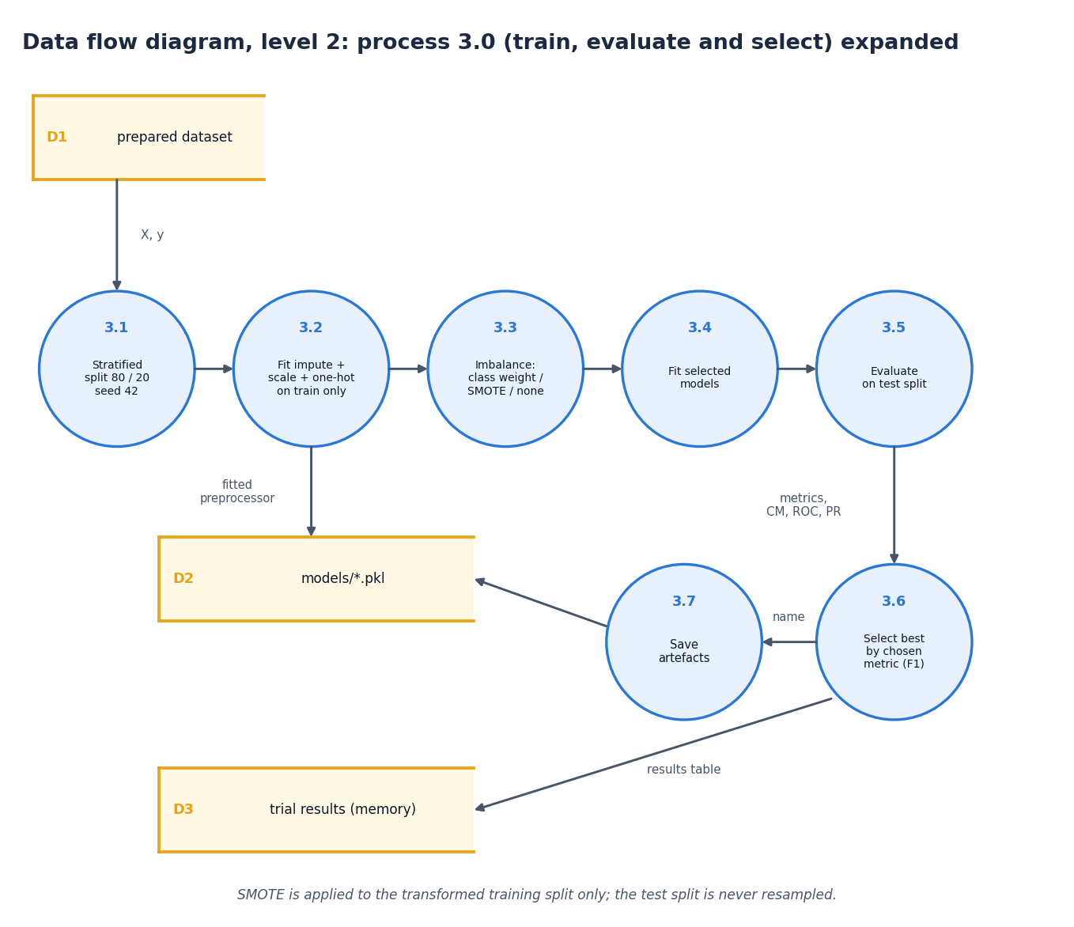
Figure 4: Data flow diagram, level 2: train, evaluate and select

5.5 Class and Sequence Design
The code base is function-oriented, so the diagram draws each module of src/ and backend/ as a class with the data it holds and the operations it offers. AppState is the only real class (a dataclass) and owns the dataset, the trial results, the active model and the risk thresholds. Arrows show which module uses which.
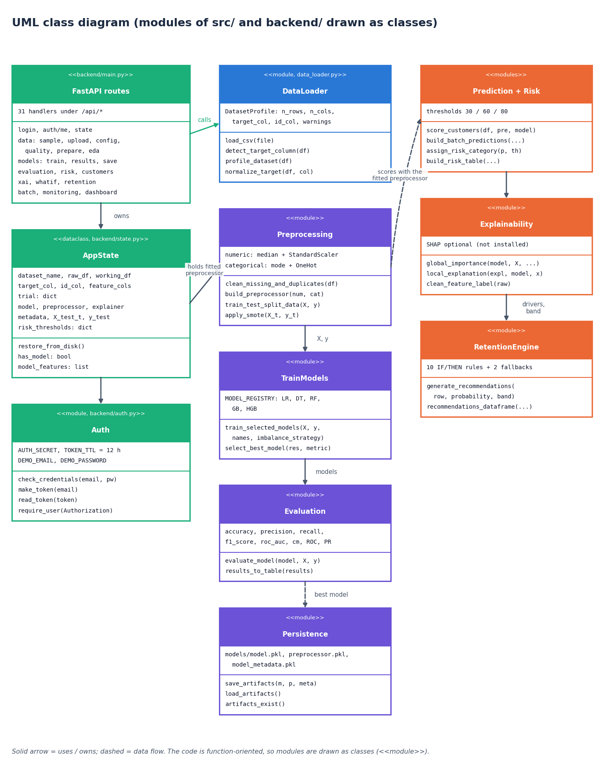
Figure 5: UML class diagram (modules drawn as classes)
The messages exchanged when an analyst signs in, loads and prepares the sample, trains and saves a model and then opens one customer. The API validates the token on every call after the login and returns the error codes listed at the foot of the figure.
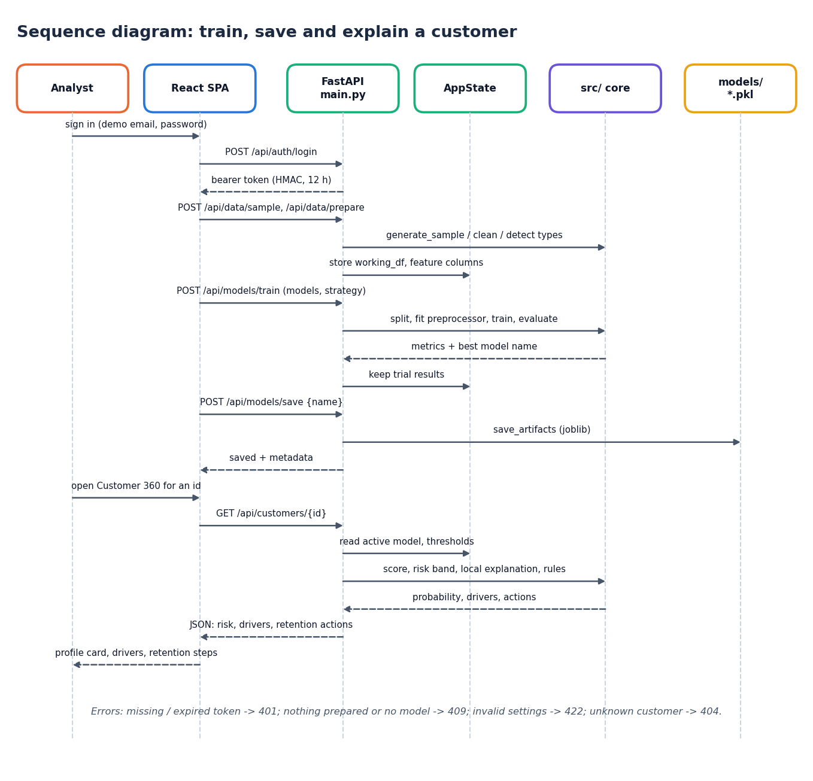
Figure 6: Sequence diagram: sign in, train, save and open Customer 360

5.6 Logical Data Model
The project has no database, so this is the logical data model of the entities the code handles: the dataset and its customers, the trial runs, the saved model artefact, the risk record of each customer, the thresholds and the recommendations. Relationships and keys are those of the in-memory tables and the files on disk.
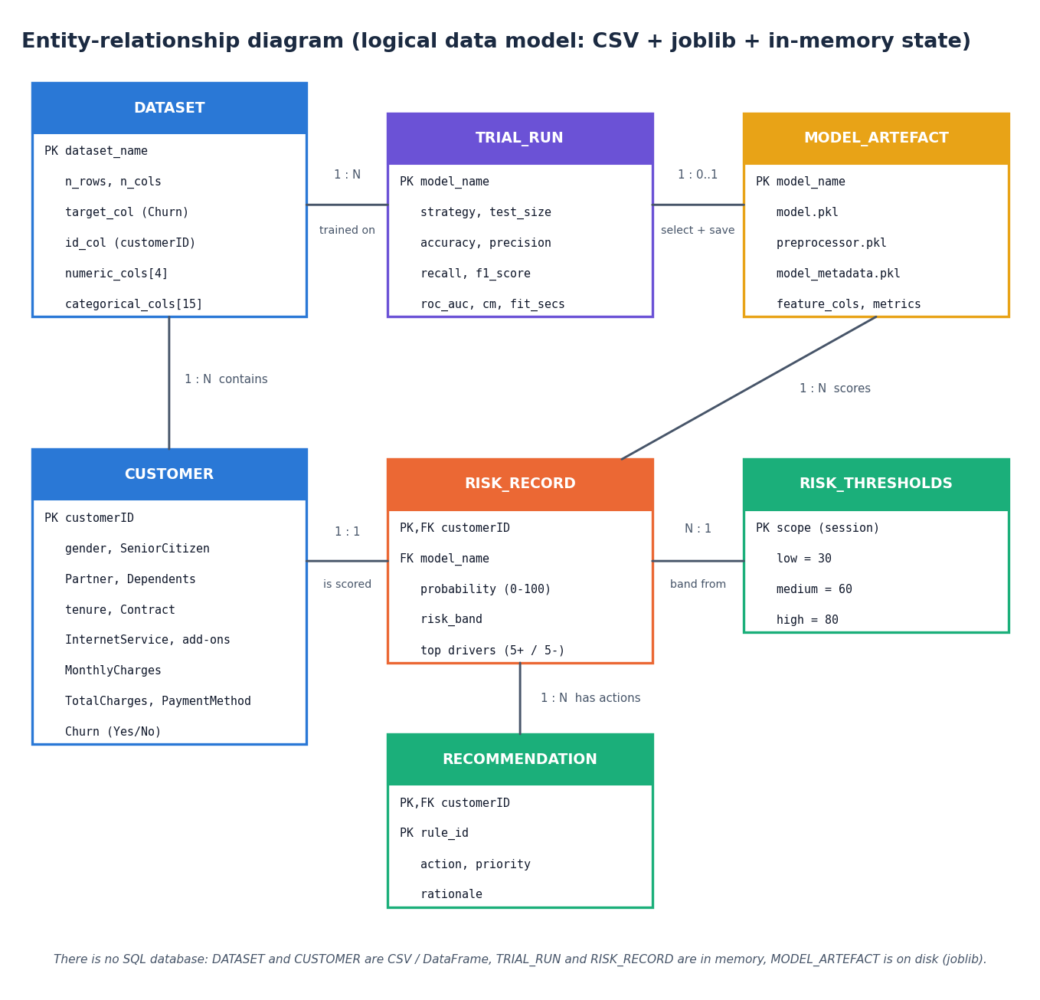
Figure 7: Entity-relationship diagram (logical data model)
Table 3: Entities of the logical data model
Entity | Where it lives | Key and content
DATASET | DataFrame in AppState; CSV on disk | Name, row and column counts, target and ID columns, lists of numeric and categorical columns
CUSTOMER | Rows of the DataFrame | customerID; the 19 feature columns; Churn
TRIAL_RUN | AppState.trial (memory) | Model name, imbalance strategy, test size, five metrics, confusion matrix, fit time
MODEL_ARTEFACT | models/model.pkl, preprocessor.pkl, model_metadata.pkl | Model name, fitted model and preprocessor, feature columns, feature names, metrics
RISK_RECORD | Computed on demand | customerID, probability 0-100, risk band, top drivers
RISK_THRESHOLDS | AppState.risk_thresholds | low 30, medium 60, high 80 by default; editable and validated
RECOMMENDATION | Computed on demand | Rule name, suggestion, linked to a customer

5.7 Algorithm Design
The decisions of the pipeline: validate the data, choose the imbalance strategy, fit and evaluate the models, select and save the best, score customers, and apply the retention rules to customers at or above 60%.
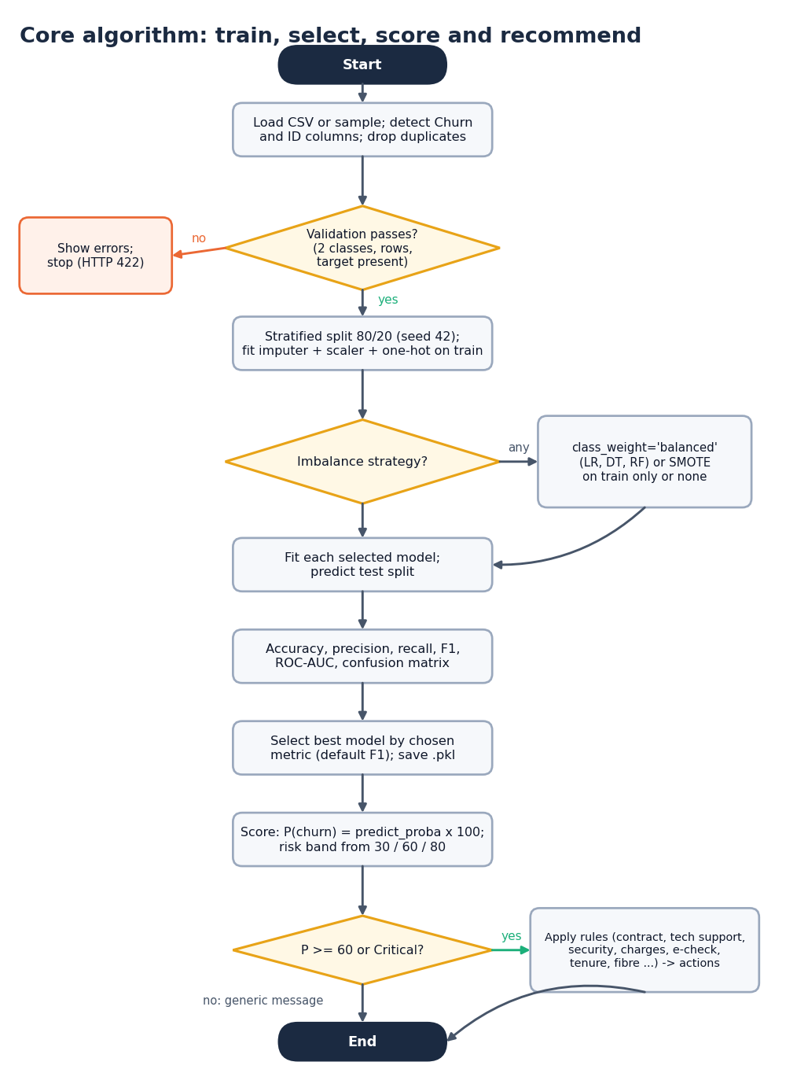
Figure 8: Flowchart of the core algorithm: train, select, score and recommend
Chapter 6 gives each step in detail. Two design decisions are worth stating here. First, model selection uses F1 by default (user-selectable among accuracy, precision, recall, F1 and ROC-AUC), because on 26% churn a model that never predicts churn has 74% accuracy. Second, the rule-based retention step is gated at 60%: nine of the ten rules require a probability of at least 60 (the High or Critical band at default thresholds) and the tenth requires the Critical band, so that low-risk customers are not sent offers.

5.8 API Design
The API follows REST conventions: nouns in paths, GET for reads, POST for actions that compute or change state, PUT for settings. All routes except health and login need an Authorization: Bearer header. Interactive documentation is served at /docs. Errors use four codes with a plain-language detail field: 401 for a missing or expired token, 404 for an unknown customer, 409 when the data or the model is not ready, and 422 for invalid input.
Table 4: API routes by group (31 handlers)
Group | Routes | Purpose
Health, auth | GET /api/health; POST /api/auth/login; GET /api/auth/me; GET /api/state | Public: health and login. Others need a bearer token
Data | POST /api/data/sample, /upload; GET /api/data/preview; GET, PUT /api/data/config; GET /api/data/quality; POST /api/data/prepare | Load, configure, check, prepare
Exploration | GET /api/eda; GET /api/dashboard | Charts, KPIs, portfolio summary
Models | POST /api/models/train; GET /api/models/results; POST /api/models/save; GET /api/evaluation | Train, compare, save, evaluate
Risk | GET, PUT /api/risk/thresholds; GET /api/risk; GET /api/customers; GET /api/customers/{id} | Bands and Customer 360
Explanation | GET /api/xai/global; GET /api/xai/local/{id}; GET /api/whatif/schema; POST /api/whatif | Drivers and scenarios
Retention | GET /api/retention | Rule-based actions
Batch, monitoring | GET /api/batch/template; POST /api/batch/predict; GET /api/monitoring; POST /api/monitoring/drift | Scoring a new CSV; drift

5.9 State and Persistence Design
AppState mirrors Streamlit's st.session_state for a single user: the raw and working data frames, the detected columns, the last training comparison (trial), the active model, its preprocessor and metadata, the cached explainer and importances and the risk thresholds. A re-entrant lock protects it because FastAPI may handle requests on several threads. Only the active model is persisted: save_artifacts writes three joblib files, and restore_from_disk loads them when the service starts. The dataset and the comparison table are session-only, as in the Streamlit application.

5.10 Security Design
• Demo credentials come from .env (DEMO_EMAIL, DEMO_PASSWORD) and are compared in constant time.
• The token is base64(payload).HMAC-SHA256(payload) with an expiry claim (12 hours); tampering or expiry makes read_token return nothing and the route answers 401.
• Uploads are accepted only as CSV and are parsed in memory; thresholds are validated server-side (Low 5-50, Medium at least 5 points above Low and at most 85, High at least 5 points above Medium and at most 95).
• This is a demonstration login with one shared account. It is not a substitute for real authentication, authorisation or audit logging on real customer data.

5.11 User-Interface Design
The ChurnIQ interface has a landing page, a demo sign-in and thirteen working pages arranged in the order of the workflow. It follows a soft pastel design kit with light and dark themes, a skip-to-content link, visible keyboard focus, reduced-motion support and layouts checked at 360, 768 and 1440 px. Each page states what it needs when a step is missing and shows plain-language errors returned by the API. The pages are shown in Chapter 8 and Appendix C.

2. IMPLEMENTATION

6.9 Explainability
Two levels of explanation are provided.
Global. global_importance returns up to three tables: the model's built-in importance (absolute coefficients for Logistic Regression, impurity-based importances for trees), permutation importance (the fall in accuracy when one feature is shuffled, computed on at most 300 test rows with 5 repeats), and, if the SHAP library is installed, mean absolute SHAP value. SHAP was not installed in the environment used for this report, so only the first two were produced and no SHAP result is reported. For the saved Logistic Regression model the largest coefficients are Contract: Month-to-month (0.825), Contract: Two year (0.791), MonthlyCharges (0.558), PaymentMethod: Bank transfer (automatic) (0.408).
Local. local_explanation explains one customer. With SHAP available it uses SHAP values; otherwise it multiplies each feature's weight (coefficient or importance) by the customer's standardised feature value:
contribution_j = weight_j x x_j (1)
The five largest positive contributions are shown as the factors pushing the score towards churn, and the five most negative as protective factors. This is an approximation of the model's behaviour for that customer, not a causal statement, and the interface labels the method used ("shap" or "approximate").

6.10 What-If Analysis
The What-if page lets the analyst change attributes of a customer (for example the contract from Month-to-month to Two year, or the monthly charge) and re-scores the edited record with the same preprocessor and model. The result is the new probability, the change in score and the new band next to the original. It is a model-based scenario analysis: it shows what the model would predict for the changed record, not what the customer would actually do.

6.11 Rule-Based Retention Engine
generate_recommendations(row, probability, band) turns a customer's profile into suggestions with transparent IF/THEN rules. There is no language model and no external service. Nine rules require a probability of at least 60 and the tenth requires the Critical band; two fallback messages cover customers for whom no rule fired.
Table 5: Retention rules
ID | Condition | Suggestion
R1 | Probability >= 60 and Contract is Month-to-month | Offer a longer-term contract with an incentive
R2 | Probability >= 60 and TechSupport = No | Proactive support outreach or a free trial of tech support
R3 | Probability >= 60 and OnlineSecurity = No | Highlight the online-security add-on in the retention conversation
R4 | Probability >= 60 and MonthlyCharges >= 80 | Check the plan against usage; present lower-cost alternatives
R5 | Probability >= 60 and PaymentMethod = Electronic check | Review the payment experience; offer an automatic payment option
R6 | Probability >= 60 and tenure <= 6 months | Early-lifecycle onboarding check-in
R7 | Probability >= 60 and InternetService = Fiber optic | Service-quality and satisfaction check-in
R8 | Probability >= 60, internet service present, no StreamingTV and no StreamingMovies | Promotional trial of streaming add-ons
R9 | Probability >= 60, PaperlessBilling = Yes and Electronic check | Billing-experience review
R10 | Risk band is Critical | Prioritise for a direct retention conversation with a case-specific offer
F1 | No rule fired and probability < 30 | Low risk: no urgent action; continue standard engagement
F2 | No rule fired and probability >= 30 | Moderate risk without a dominant factor: general satisfaction check-in; monitor the account

Every suggestion carries the reason that produced it, so a retention agent can see why it appears. The thresholds in the rules (60, 80 charges, 6 months) were chosen by the team as reasonable starting points; their business effect was not measured, because there are no campaign data.

6.12 Batch Prediction and Monitoring
The Batch page scores a CSV in one step. The file must contain the feature columns the active model was trained on; otherwise the API answers 422 and names the missing columns. The output table has the customer ID, the churn probability, predicted_churn (Yes when the probability is at least 50), the risk band and, optionally, the three largest risk factors (on by default, up to 300 rows). A template with 25 rows can be downloaded.
The Monitoring page shows the active model's details and, for a new file, a drift check against the data the model was trained on: columns that are missing, the percentage of missing values (flagged above 10%), categories not seen in training, the shift in the mean of each numeric field, and the churn rate of the new file when it has a target column. It is a simple screening tool; it does not compute statistical drift tests.

6.13 API Implementation
backend/main.py defines, with FastAPI [21], the routes in two routers: public (health, login) and private (all others), the latter protected by the dependency require_user, which reads the bearer token. Each handler loads or updates STATE, calls the matching functions of src/ and returns JSON in a common envelope. Helper functions convert numpy and pandas values, find a customer by ID, build the risk table and the explanation of one row. A background thread warms the importance cache after a model is saved, and a lock stops a request and the warm-up from computing it twice. CORS is configured for the development origin of the web interface, which also reaches the API through the Vite proxy.
def make_token(email: str) -> str:
body = _b64(json.dumps({"sub": email, "exp": int(time.time()) + config.TOKEN_TTL_SECONDS}).encode())
return f"{body}.{_sign(body)}"

def read_token(token: str) -> dict | None:
try:
body, sig = token.split(".", 1)
if not hmac.compare_digest(sig, _sign(body)):
return None
data = json.loads(_unb64(body))
return data if data.get("exp", 0) > time.time() else None
except Exception:
return None

The listing shows the token functions of backend/auth.py: the token is a base64 payload plus an HMAC-SHA256 signature, and read_token returns nothing for a bad signature, an expired token or a malformed string.

6.14 ChurnIQ Web Interface
The interface is a React 19 single-page application built with Vite 8. It has a landing page, a demo sign-in and thirteen working pages (Dashboard, Data, Explore, Train, Evaluation, Customer risk, Customer 360, Explain, What-if, Retention, Batch, Monitoring, About), routed with React Router 7. Charts use Recharts, motion uses Framer Motion and GSAP, and the styling is a soft pastel kit with light and dark themes. During development Vite serves the pages on port 5314 and proxies /api to the FastAPI service on port 8314, so no cross-origin calls occur. The token is kept in the browser's local storage and sent as a bearer header; a 401 on any call except the login ends the session and returns the user to the sign-in page.

6.15 Original Streamlit Application
The Streamlit application (app.py and thirteen modules in pages/) was the first interface and remains runnable (streamlit run app.py, port 8501). Both interfaces call the same src/ functions. Streamlit keeps its state in st.session_state; the FastAPI layer reproduces that with AppState, so both behave the same way.

6.16 Running the System
From the project folder, run.bat creates the virtual environment, installs the Python and Node packages and starts the API and the web interface. The sample data and the saved model are used automatically. Appendix B gives the commands, the demo credentials and the order in which to use the pages.

3. KEY CODE WALK-THROUGHS
The excerpts below are taken unchanged from the code base and explain how the central steps are implemented.

3.1 Building the preprocessor (src/preprocessing.py)
A single ColumnTransformer treats numeric and categorical fields differently. Because it is fitted on the training split only and reused unchanged for scoring, the same transformation is applied at training and in the application.
def build_preprocessor(numeric_cols: list, categorical_cols: list) -> ColumnTransformer:
numeric_pipeline = Pipeline(steps=[
("imputer", SimpleImputer(strategy="median")),
("scaler", StandardScaler()),
])
categorical_pipeline = Pipeline(steps=[
("imputer", SimpleImputer(strategy="most_frequent")),
("onehot", OneHotEncoder(handle_unknown="ignore")),
])
transformers = []
if numeric_cols:
transformers.append(("num", numeric_pipeline, numeric_cols))
if categorical_cols:
transformers.append(("cat", categorical_pipeline, categorical_cols))

preprocessor = ColumnTransformer(transformers=transformers, remainder="drop")
return preprocessor

3.2 Training and comparing models (src/train_models.py)
train_selected_models fits each requested model under the chosen imbalance strategy and evaluates it on the same test split. SMOTE is applied to the training matrix only; class weights are passed only to the models that accept them.
def train_selected_models(
X_train, y_train, X_test, y_test,
model_names: list,
imbalance_strategy: str = "class_weight", # "none" | "class_weight" | "smote"
):
"""Train each requested model and evaluate it on the held-out test
set. Returns (trained_models: dict, results: dict[name -> metrics]).

imbalance_strategy:
- "class_weight": pass class_weight='balanced' to models that support it
- "smote": oversample the (already-preprocessed, numeric) X_train via SMOTE
- "none": train as-is
"""
trained_models = {}
results = {}

X_tr, y_tr = X_train, y_train
if imbalance_strategy == "smote":
from preprocessing import apply_smote
X_tr, y_tr = apply_smote(X_train, y_train)

class_weight = "balanced" if imbalance_strategy == "class_weight" else None

for name in model_names:
if name not in MODEL_REGISTRY:
continue
builder = MODEL_REGISTRY[name]
# Gradient boosting variants don't accept class_weight
try:
model = builder(class_weight=class_weight)
except TypeError:
model = builder()

model.fit(X_tr, y_tr)
trained_models[name] = model
results[name] = evaluate_model(model, X_test, y_test)

return trained_models, results

def select_best_model(results: dict, metric: str = "f1_score"):
"""Pick the model with the highest value of `metric` (not accuracy
alone, per project requirement -- default is F1)."""
if not results:
return None
best_name = max(results, key=lambda k: results[k][metric])
return best_name

3.3 Risk bands (src/utils.py)
def assign_risk_category(probability_pct: float, thresholds: dict = None) -> str:
"""Map a churn probability (0-100) to a risk band using configurable
thresholds. `thresholds` has keys 'low', 'medium', 'high' marking the
upper boundary (in %) of the Low, Medium and High bands respectively;
anything above 'high' is Critical.
"""
t = thresholds or DEFAULT_RISK_THRESHOLDS
if probability_pct < t["low"]:
return "Low Risk"
elif probability_pct < t["medium"]:
return "Medium Risk"
elif probability_pct < t["high"]:
return "High Risk"
else:
return "Critical Risk"

3.4 Local explanation with a fallback (src/explainability.py)
When SHAP is unavailable (the case in this report) the explanation multiplies each feature's weight by the customer's standardised value; the third returned item tells the interface which method was used.
def local_explanation(explainer, model, x_row_transformed, feature_names, top_n: int = 5):
"""Explain a single customer's prediction. Returns
(top_positive: list[(feature, value)], top_negative: list[(feature, value)])
where 'positive' means the feature pushed the prediction TOWARD
churn and 'negative' means it pushed AWAY from churn.

Falls back to a coefficient/importance x value heuristic if SHAP is
unavailable, so the app remains functional either way.
"""
x_row_transformed = np.atleast_2d(x_row_transformed)

if explainer is not None:
try:
shap_vals = _shap_values_for_positive_class(explainer, x_row_transformed)[0]
pairs = list(zip(feature_names, shap_vals))
pairs.sort(key=lambda p: p[1], reverse=True)
top_pos = [(f, v) for f, v in pairs if v > 0][:top_n]
top_neg = [(f, v) for f, v in pairs if v < 0][-top_n:][::-1]
return top_pos, top_neg, "shap"
except Exception:
pass

# ---- Fallback: importance-weighted feature value heuristic ----
if hasattr(model, "feature_importances_"):
base_importance = model.feature_importances_
elif hasattr(model, "coef_"):
base_importance = model.coef_.ravel()
else:
base_importance = np.ones(len(feature_names))

contrib = base_importance * x_row_transformed[0]
pairs = list(zip(feature_names, contrib))
pairs.sort(key=lambda p: p[1], reverse=True)
top_pos = [(f, v) for f, v in pairs if v > 0][:top_n]
top_neg = [(f, v) for f, v in pairs if v < 0][-top_n:][::-1]
return top_pos, top_neg, "approximate"

3.5 Scoring (src/prediction.py)
def score_customers(df_features: pd.DataFrame, preprocessor, model) -> np.ndarray:
"""Return churn probability (0-100 scale) for each row of
df_features (raw, untransformed feature columns)."""
X_t = preprocessor.transform(df_features)
proba = model.predict_proba(X_t)[:, 1]
return np.round(proba * 100, 2)

def validate_columns_for_prediction(new_df: pd.DataFrame, required_cols: list) -> list:
"""Check that a newly-uploaded dataframe (for batch prediction) has
the columns the trained model expects. Returns a list of problems."""
problems = []
missing = [c for c in required_cols if c not in new_df.columns]
if missing:
problems.append(f"Missing expected column(s): {', '.join(missing)}")
return problems

3.6 Token check (backend/auth.py)
def make_token(email: str) -> str:
body = _b64(json.dumps({"sub": email, "exp": int(time.time()) + config.TOKEN_TTL_SECONDS}).encode())
return f"{body}.{_sign(body)}"

def read_token(token: str) -> dict | None:
try:
body, sig = token.split(".", 1)
if not hmac.compare_digest(sig, _sign(body)):
return None
data = json.loads(_unb64(body))
return data if data.get("exp", 0) > time.time() else None
except Exception:
return None

4. IMPLEMENTATION DECISIONS AND THEIR REASONS
Table 6: Implementation decisions and their reasons
Decision | Reason
All logic in src/, interfaces as thin callers | Both interfaces give identical results; the core can be tested without a server
Fit the preprocessor on the training split only; SMOTE on the training split only | Prevents information from the test split reaching the model
Select the model on F1 by default | On 26% churn accuracy rewards a model that never predicts churn; the experiment shows recall of 0.19 with 0.745 accuracy
Class weights as the default imbalance strategy | Simple, no synthetic rows, works with all three required models
Fixed hyper-parameters, no search | Keeps the comparison reproducible and fast; a search on 800 rows would overfit the validation noise
Coefficient-times-value as the local fallback | Exact contribution to the log-odds for Logistic Regression; cheap; works without SHAP
Rules gated at 60% | Avoids sending offers to customers the model considers unlikely to leave
Server-side validation of thresholds and files | The interface cannot create an impossible state; errors are plain-language
HMAC bearer token instead of sessions | Stateless and dependency-free; suitable for a demonstration login
Single in-memory AppState with a lock | Mirrors Streamlit's session state; adequate for one user
Report cross-validation and repeated splits | A 200-row test set is too small to rank similar models

